Q 1) IMPORT DATA FROM CSV TO R AND CREATE A 3 BY 3 MATRIX
MARK: 23,32,34,41,45,52,17,14,18
OUTPUT:
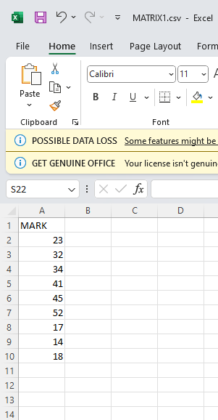

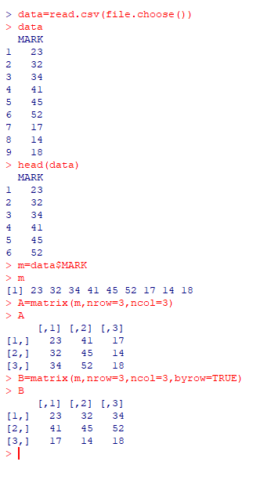

Q 2) CONSTRUCT TWO MATRICES AND PERFORM MATRIX OPERATIONS
A=12,14,10,17,15,22,23,21,20
B=22,28,29,10,17,14,15,22,23
COMMANDS:
data=read.csv(file.choose())
head(data)
ma=data$A
mb=data$B
A=matrix(ma,nrow=3,ncol=3)
B=matrix(mb,nrow=3,ncol=3)
A=matrix(ma,nrow=3,ncol=3,byrow=TRUE)
B=matrix(mb,nrow=3,ncol=3,byrow=TRUE)
A+B
A-B
A%*%B
solve(A)
solve(B)
qr(A)$rank
qr(B)$rank
t(A)
t(B)
diag(A)
diag(B)
cbind(A,B)
rbind(A,B)

OUTPUT:

